1 Excel Template 1

1.1 Entities 1

1.2 Fields 1

1.3 Relationships 1

1.4 Option Sets 1

1.5 Views 1

1.6 Execute Import 1

This feature is designed to improve the creation and updating customisations in CRM

Entities, fields, many to many relationships, option sets and some system views may be entered into an excel spreadsheet and uploaded into crm in bulk

# Excel Template

A template containing example customisations to import may be accessed by clicking “Import Customisations Sample’ on the main menu

The Excel template contains 4 tabs for customisation components. View customisations are included in the fields tab

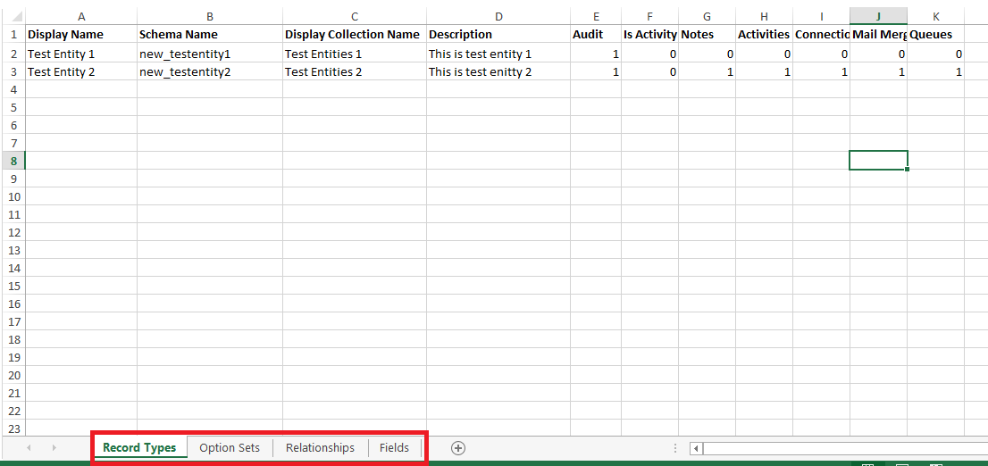

## Entities

Entity customisations are defined on the ‘Record Types’ tab. Note all Schema Names should use lower case

If you are creating a new entity then it is required to add a string field for that entity to the ‘Fields’ tab with ‘Is Primary Field’ set to true

## Fields

Fields are defined in the ‘Fields’ tab. Note all Schema Names should use lower case

The ‘Record Type Schema Name’ with the record type for that field

Some fields are or aren’t required depending on the type of field. For example Max Length will need to be populated for a string type field and Minimum and Maximum will need to be populated for an Integer or Decimal type field

Picklist options can be defined for a Picklist field by referencing the name of an Option Set in the ‘Option Sets’ tab

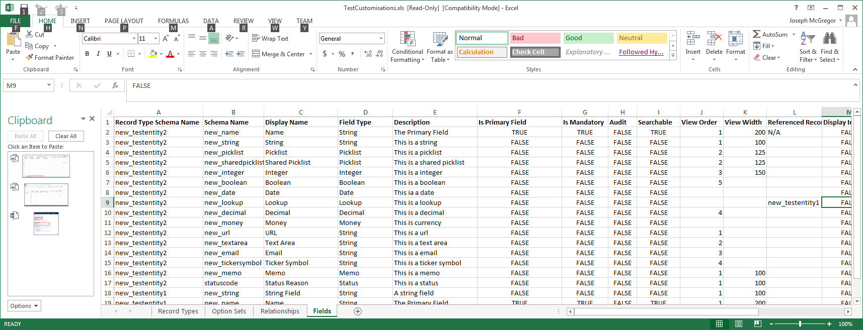

## Relationships

N to N Relationships may be defined in the ‘Relationships’ tab. This just imports/updates N to N relationships between entities. Always use lower case for schema names

## Option Sets

Field specific or shared option sets may be imported from the ‘Option Sets’ tab. Always use lower case for schema names

Option Set Name is required to be referenced from the Picklist Options column of the ‘Fields’ tab if they are to be set for a particular field

Note if a field label is a number then it is required to prefix it with ‘TXT_’ so the Excel file does not read the column as numbers. E.g. for a label of ‘60’ set it as ‘TXT_60’

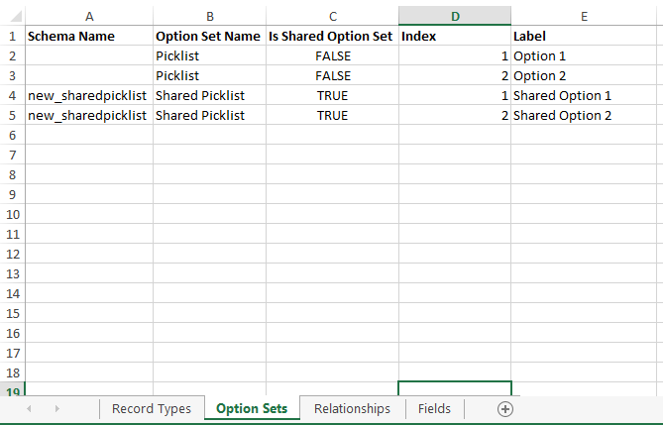

## Views

Views are defined in the ‘Fields’ tab. The application will update a set of system views for an entity type as defined. Sort By And Filters cannot be defined in the spreadsheet

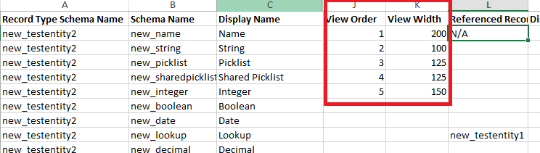

## Execute Import

To Execute the import select the ‘Customisation Import’ button from the top of the screen

You then need to select the MS Excel file containing the customisations to import and check the specific component types to import

You may elect to only import/update the fields and/or entities or any other combination of the component types

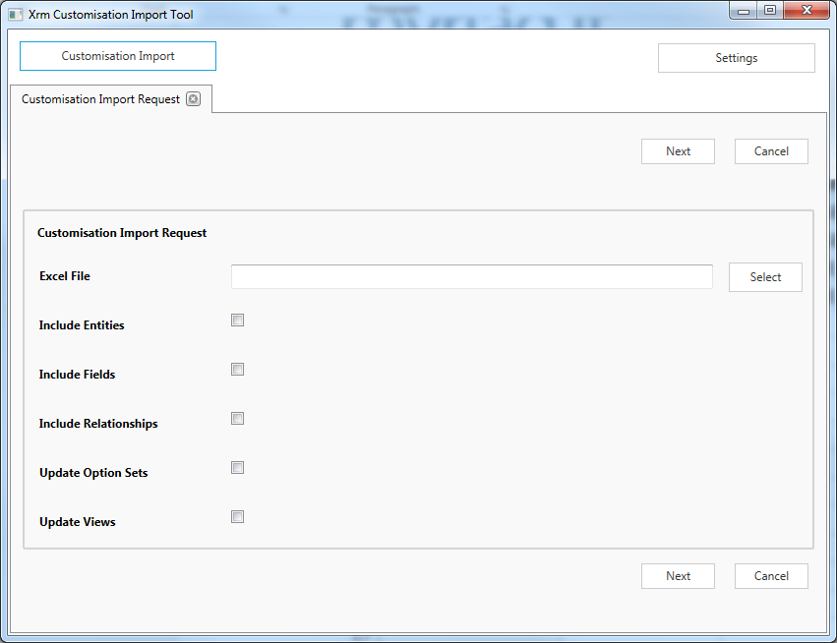

When ‘Next is click the system will then proceed to execute the import

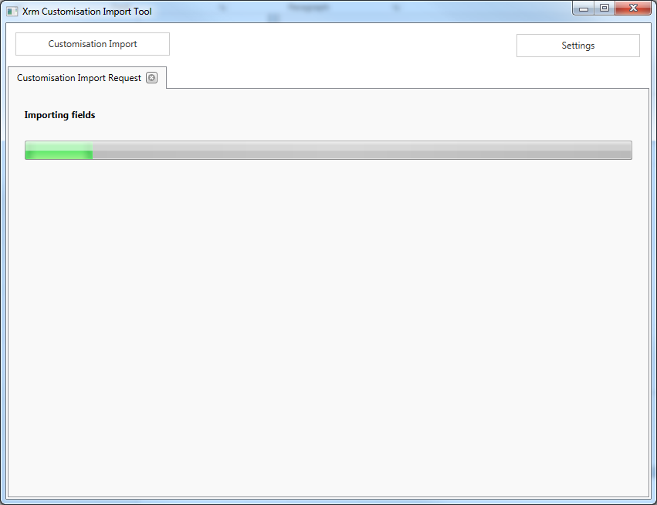

Then display a details of the imported items including any errors

